Web Development Task:  
  
Here's a [Marvel UI link](https://marvelapp.com/46583ic/screen/55479041) for a web page that we would like you to HTMLize and also make it responsive. You are free to use any JS framework/library.  
  
Interactions :

1) Selecting the number of Serving  
  
  
2) Toggling Between annual and monthly billing section  
  
  
The above interaction should change the details in the card below.   
**Your savings with lollipop** is the difference between the Icecandy and lollipop for a year/month.  
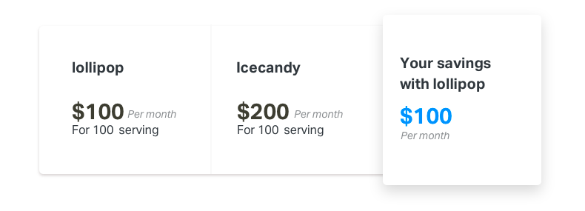

For the pricing calculation you can refer the table below:

|  |  |
| --- | --- |
| lollipop | Price (per serving) |
| Annually | 0.5$ |
| Monthly | 1$ |

|  |  |
| --- | --- |
| Icecandy | Price (per serving) |
| Annually | 1$ |
| Monthly | 2$ |

In Marvel, you can use the handoff feature to check the CSS of the given design. You can find that option on the bottom left of the screen. Also in the handoff mode of marvel, you can download all the assets defined on the page by just clicking on any asset you would like to download.

Host it in Heroku - you can sign up for a free account in Heroku. E.g. [Here are steps](https://devcenter.heroku.com/articles/getting-started-with-python) on how you can get a Django app running in Heroku in a few minutes.